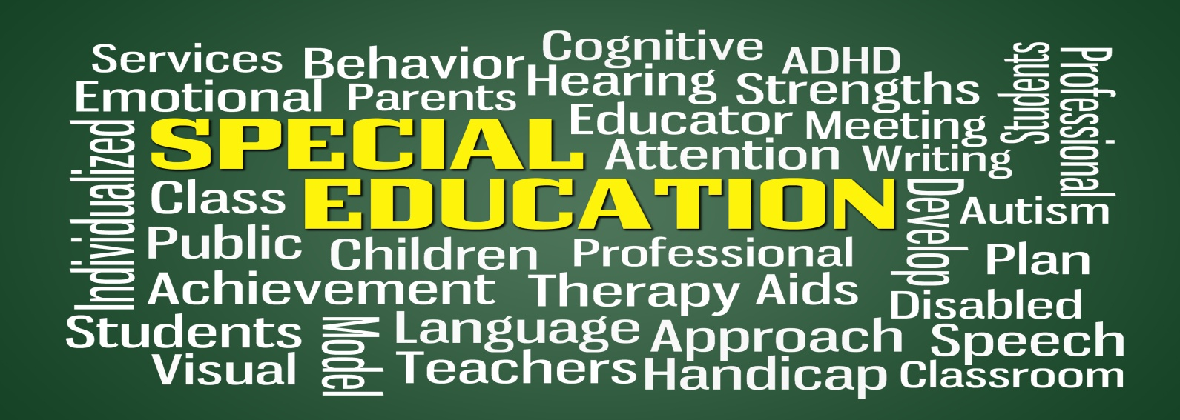

FREE PRESENTATION:
Individualized Education Plan: The Basics
November 29, 2016 10:30 – 11:30 a.m.
The Pleasanton Library, 400 Old Bernal Ave., Pleasanton, CA
(Community Room)
Topics Include:
- Introduction to federal and state law
- Assessments
- IEP Meetings
- Goals
- Services
- Current Hot Topics

Details:
Presented by Kristin Springer, The Law Office of Kristin Springer
Note: The event is open to the public
RSVP to specialedlegaljourney@comcast.net

